**CS551**

**Advanced Software Engineering**

**Spring 2015**

**Submitted by**

**PG-10**

**Bhuvana Atluri (Class ID: 3)**

**Bhargavi Vepuri (Class ID: 52)**

**Spandana Surapaneni (Class ID: 47)**

**Venkata Nagaraj Voonna (Class ID:53)**

**INDEX**

**I. Deployment**

**II. User Manual**

**III. Project Management**

**IV. Project Proposal**

**V. Project Plan**

**VI. Increment 1**

**VII. Increment 2**

**VIII. Increment 3**

**IX. Increment 4**

**X. Presentation Material**

**XI. References**

**XII. Acknowledgement**

**I. Deployment:**

**Source code:** [**https://github.com/Spandana11/Increment4**](https://github.com/Spandana11/Increment4)

**Project video:** [**https://www.youtube.com/watch?v=wdVPcOZ1tKM**](https://www.youtube.com/watch?v=wdVPcOZ1tKM)

**II. User Manual:**

**Introduction:** In most of the times, we are busy and involved in our work and couldn’t attend every call. If we concentrate on attending the calls we will be deviated from our work. What if there is an application which would help us to intimate the caller automatically our reason for not attending the call?

This is what our application “**Auto Profile**” is exactly meant for!!!

Our application automatically sends message, image and email to the caller whenever a call is not attended and missed call is triggered. An additional feature is that if the caller replies with “help” message an alarm notification will be ringed to notify the receiver that the caller is in emergency situation and he must communicate with the caller immediately. An alarm notification will be ringed independent of the phone mode.

**How to use system:** The deployed code can be found on GitHub and could be downloaded to one’s system. After downloading the code, run the code using Android SDK. Connect your smart device to the system and it acts as emulator. After running the code, the application will be installed on the device.

**Error recognition and handling:** The desired profile will be activated automatically if the profile time and the device time are matched.

**Sample interaction:** After the application is installed, user can add profile by setting profile name and the message for the profile. After adding the profile user must set from time and to time to the profile which tells the application when the profile must be activated. There is an option to add an image too, to convey our message effectively. Whenever a caller calls and if a profile is set for that particular time then an automatic message, email and message will be send to the caller.

**Bugs and deficiencies:** Sometimes the application stops automatically if it is not in use with no reason.

**III. PROJECT MANAGEMENT**

**Summary:**

Agile process is the software development method we have used. We have divided the project plan into four increments where each increment included improvements in both back end and front end implementation from increment to increment. We have used Scrum Do for our project management and for maintaining the project artifacts. A scrum master is the facilitator for a product development team that uses scrum, a rugby analogy for a development methodology that allows a team to self-organize and make changes quickly.  The scrum master manages the process for how information is exchanged.  Our team consists of four members and the project development has been shared equally between all of us. In each phase every member implemented a unique feature and contributed to the successful completion of application.

The below are the tasks that have been scheduled in each of the increments:

If there are any pending backlogs we all worked together to nullify them.

**First Increment:**

1. As the developer, I need to develop a user interface for the creation of auto profile application so that users can create their profile – Bhuvana Atluri

2. As a system, I want to store the input data given by the user into the database so that user access the data when required – Spandana Surapaneni

3. As a user, I need to add a profile so that I can intimate the caller when I can't attend a call. – Bhargavi Vepuri

4. As a user, I can create multiple profiles with different timings – Nagaraj Voonna.

**Scrum Do Link:**

You can find the related work and Scrum Do stories here:

<https://www.scrumdo.com/projects/project/plan4/iteration/121763/board>

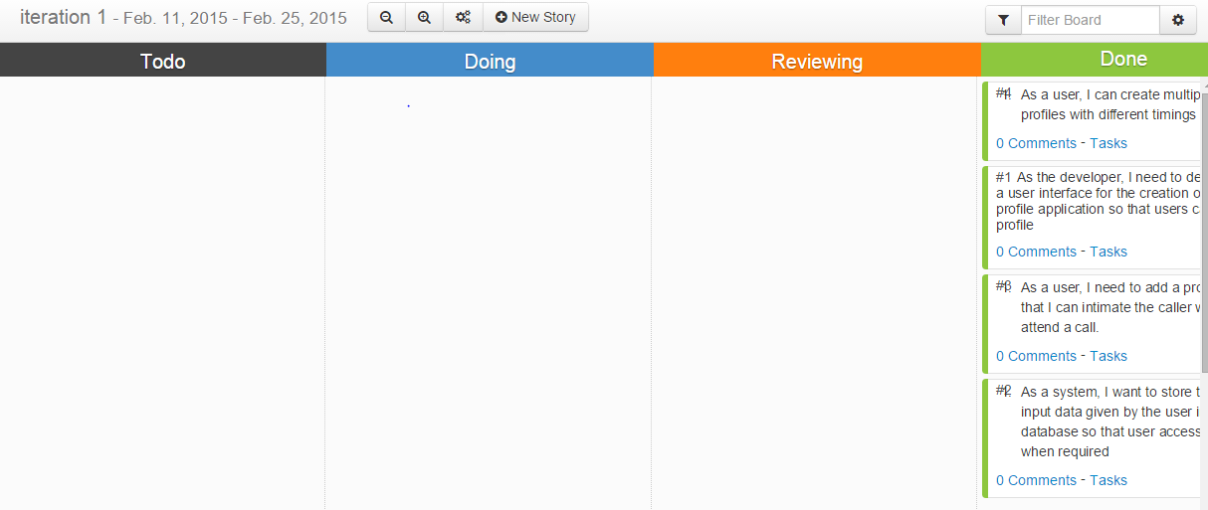

**Second Increment:**

1.As a developer, I need to retrieve the input data given by the user from the database so that the application can use the data – Bhuvana Atluri

2. As a developer, I need to mention the cases where the application should start working - Bhargavi

3. As a developer, I need to build a service to broadcast the message to the caller – Spandana

4. As a developer, I need to build a service to notify the message is sent or not.- Nagaraj Voonna

**ScrumDo Link:**

You can find the related work and Scrum Do stories here:

<https://www.scrumdo.com/projects/project/plan4/iteration/121763/board>

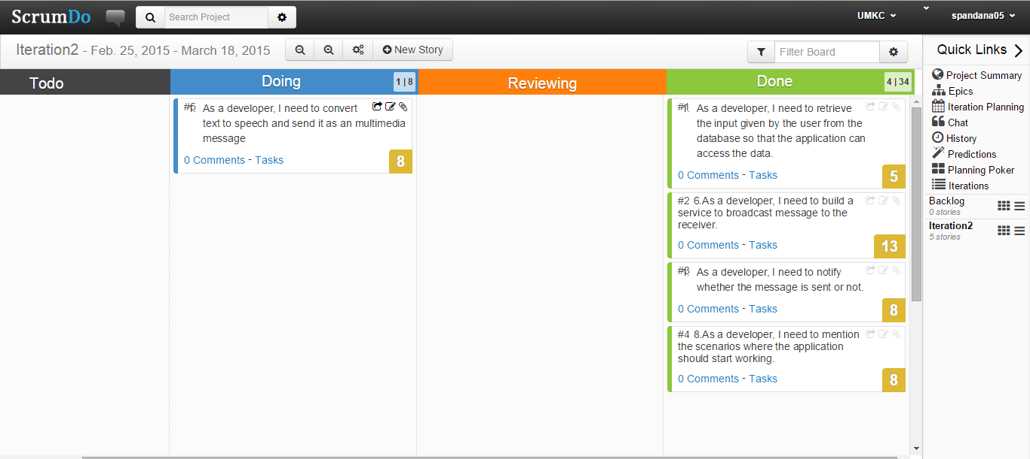

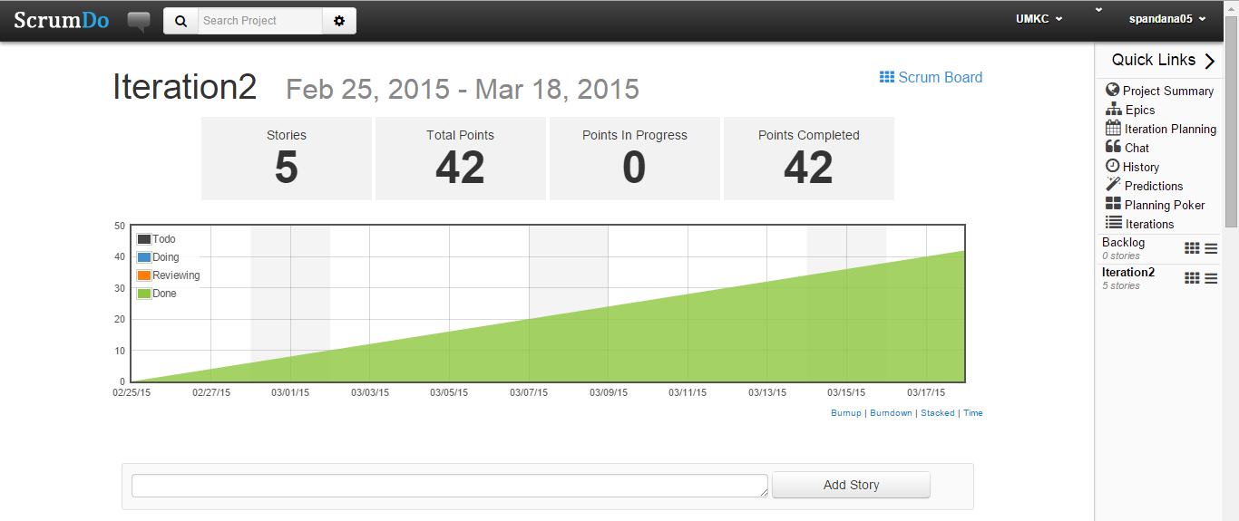

**Third Increment:**

1. As a developer, I need to send an email to the caller in order to inform him the reason for not attending the call– Bhuvana
2. As a developer, I am sending a picture to the caller as an mms for better view – Bhargavi
3. As a developer, I should be able to delete profiles which I feel unwanted – Spandana
4. As a developer, I should make sure, that at the same time two profiles should not be added – Nagaraj

**ScrumDo Link:**

You can find the related work and ScrumDo stories here:

<https://www.scrumdo.com/projects/project/plan4/iteration/121763/board>

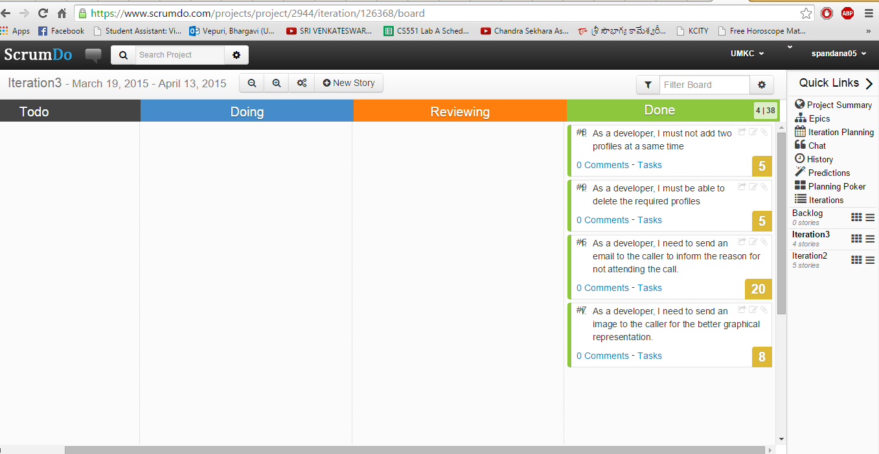

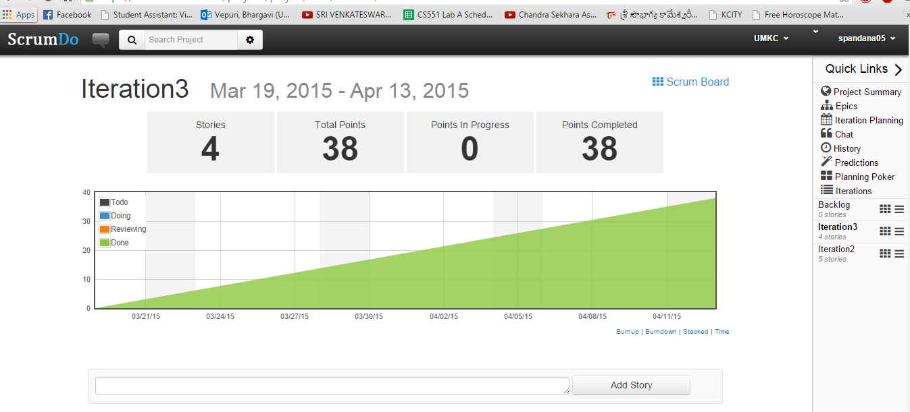

**Fourth Increment:**

1. As a developer, I need to filter messages received and determine if any message consists of “help”– Bhuvana, Bhargavi
2. As a developer, I need to notify the receiver with notification sound – Spandana, Nagaraj

**ScrumDo Link:**

You can find the related work and ScrumDo stories here:

<https://www.scrumdo.com/account/login/?next=/projects/project/ase-1/iteration/127057>

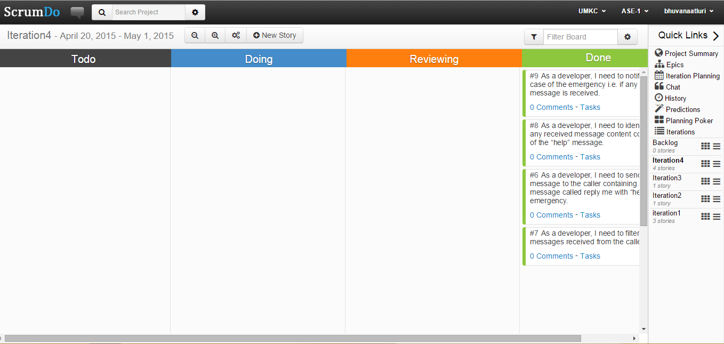

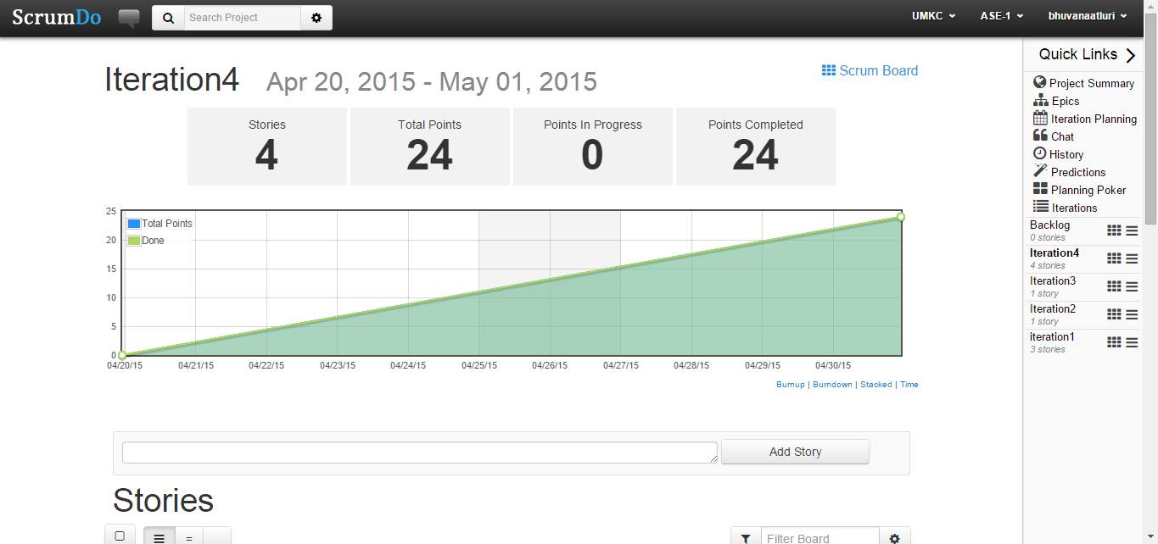

**IV. PROJECT PROPOSAL**

**Motivation**: In the present busy world, people are engaged in many works and may not be able to attend all the phone calls. Even though he can notify the calling person by sending a message manually. But to do this he have to pay attention to the phone, which ultimately drags out focus on work. So to overcome this situation we propose an auto profile application. Auto profile process means it automatically shifts the profile in time intervals, if we have not attended the call it automatically sends the message, picture and email to the concerned call person. Along with these features if the called person replied with the “help” message then an automatic alarm will be triggered.

**Significance**: The beauty of our project lies in, that we need not consider about the calls when we are in some important meeting or not in a position to attend the call. Automatically profile is activated which we schedule it and sends message to concerned call person. As this is a mobile application one can easily organize his profile whenever he want to perform a particular task as per his requirement.

* This makes sure to have total focus on preferred tasks without considering incoming calls.
* And the person who called will also be notified automatically about the present situation of the one who he called.

**Objectives:** The goal of auto profile system reduces the communication gap between the caller and the receiver whenever the receiver is unable to attend the call. In this application the caller is able to know the reason for not attending the call. In the same way the receiver will also be benefited, i.e. he can concentrate or focus on his work without being interrupted.

**System features**:

* Coding Language : Java (JDK 1.6) or Android SDK
* IDE : Eclipse or Indigo IDE
* Database : SQL Server 2008

**Related work:** At present smart phones have an option to send a message to the caller whenever a call is rejected, but the message should be send manually, there is no option to send a message automatically whenever a call is ended or rejected.

**Our Application**: Autoprofile is an application developed for android platform, used to create and organize tasks or actions one need to get done. This reveals one from the stress of remembering everything one need to do. As this is a mobile application one can easily organize his actions. By using this application we can send a message automatically to the caller that we are not in a position to attend the call by creating the customized messages such as I am in meeting etc. Whenever we are not in a position to attend the call we can use this application to automatically intimate the profile to the caller. It provides messages to all the persons, not only to the saved contact number but also to the unsaved numbers called at that particular time.

**Bibliography:**

<http://developer.android.com/index.html>

<http://android-developers.blogspot.com/>

**V. PROJECT PLAN**

**I. Introduction:**

In the present engaged world, individuals are occupied with numerous works and will be unable to receive all the mobile calls. Despite the fact that he can intimate the calling individual by manually sending a message. However to do this he need to pay consideration on the mobile, which at last drags out spotlight on work. So to beat this circumstance we propose an auto profile application. Auto profile procedure implies it consequently moves the profile in time intervals, if we have not attended the call it automatically sends the message to concerned call person.

**II. Project Goal and Objectives (revised)**

**Overall goal:** When we are in some critical gathering or not in a position to go to the call. Naturally profile is enacted which we plan it and sends message to concerned call individual. As this is a portable application one can without much of a stretch compose his profile at whatever point he need to perform a specific errand as every his necessity.

* Permits complete spotlight on tasks without agonizing over approaching calls.
* Client can choose the timings and profile mode depending up on necessities.

**Specific objectives (problem statement):** In Existing system we can only set the profile (profile activation) of the user manually that is whenever we are not in a position to attend the call we cannot send any message automatically but we can send it manually afterwards not at the particular time and we have no such applications to alert the important persons automatically whenever we can are not in a position to attend the call. So we propose this Auto profile as solution.

**Significance:** In the proposed framework an application is developed on android platform, which is utilized to make custom profile and compose tasks which we plan according to our prerequisite. This helps such that we need not consider about the calls when we are in some essential gathering or not in a situation to attend to the call. Consequently profile is initiated which we plan and sends message to concerned call individual. As this is a versatile application one can undoubtedly sort out this activity at whatever point we need to perform a specific assignment according to our necessity.

Advantages:

* Allows complete focus on tasks without worrying about incoming calls.
* User can select the timings and profile mode depending up on requirements.

**III. Project Background and Related Work:**

Now-a-days one of the rapidly growing industries are mobile industries. There are numerous competitors who are doing innovative work on new stages & client experience. One such innovation is Android from Google which is upheld for Google mobiles. Utilizing this android stage we can create tweaked applications. Until now we have a facility to send message manually whenever we reject a call. But there is no such application to send customized messages automatically without the involvement of user whenever the call is missed.

**IV. Proposed System**

**1) Requirement Specification**

**Functional:**

The application sends a message to the caller whenever the called person does not respond. In order to do this first the user has to create a profile. In that profile he specifies the time period and the message to be delivered. Once the profile is saved then automatically a message will be delivered to the caller. The user can set multiple profiles depending on the requirement. For example he can set profiles for 2pm as “I am in a meeting” and at 3pm “I am in driving”. The application must be able to switch between these multiple profiles. The user can activate, deactivate, update, or delete his profile at any time. He can also verify the message which is delivered to which person.

**Non Functional:**

Nonfunctional requirements mainly defines the quality and the implementation of the system. The performance of the application depends on the real time response for all the activities performed by the user. Validation of the inputs provided by the user i.e. two profiles cannot be created at the same time as the user cannot be have two profiles at the same time.

**System features:**

Coding Language : Java (JDK 1.6) or Android SDK

Database : Microsoft SQL Server 2008

IDE : Eclipse or Indigo IDE

**2) Framework Specification**

**Assumptions and Principles**

* The mobile should support android operating system.
* The mobile should have sufficient SMS credits.
* The one who is using the mobile must have a minimum knowledge how to create profile in the application and add multiple profiles in the application.

**Activity Diagram:**



**System Architecture Diagram:**

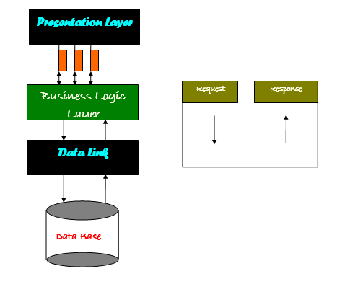

**3) System Specification:**

**Existing Services:**

1. Name: Messaging Service

Description: Messaging Service is used to send messages between the mobile devices using the mobile network

URL: <http://developer.android.com/reference/android/os/Message.html>

2. Name: SMS Scheduler

Description: SMS scheduler allows to create new text messages and schedule a time to send the message to the recipient.

URL: <https://play.google.com/store/apps/details?id=com.gizmoquip.smsscheduler>

**New Services to be built:**

**1. Create Profile:** A profile is created with the profile details like profile name, time for profile activation, specified message for the profile.

Input: Creation of Profile based on the desired requirements

Output: Profile is created successfully.

**Class Diagram:**



**Sequence Diagram:**



**2. Auto Profile Activation**: Profile activation initializes the service for the profile whenever recipient can’t attend the call from the caller.

Input: Whenever a call is missed Autoprofile is activated.

Output: Specified message is sent to the caller.

Class Diagram:



**Sequence Diagram:**



**3. Auto Profile Switching**: Auto Profile switching switches between the different profiles depending on the time intervals scheduled by the user.

Input: Multiple profiles are created depending on different times.

Output: Message is send to the recipient depending on the time by switching between the profiles.

**Class Diagram for Overview of Project:**



**Design of Mobile Client:**

Technologies used to develop this application are:

**For Frontend design:**

Eclipse IDE, Java JDK 1.6

**Backend:**

Microsoft SQL Server 2008

**V. Plan by Services (using ScrumDo):**

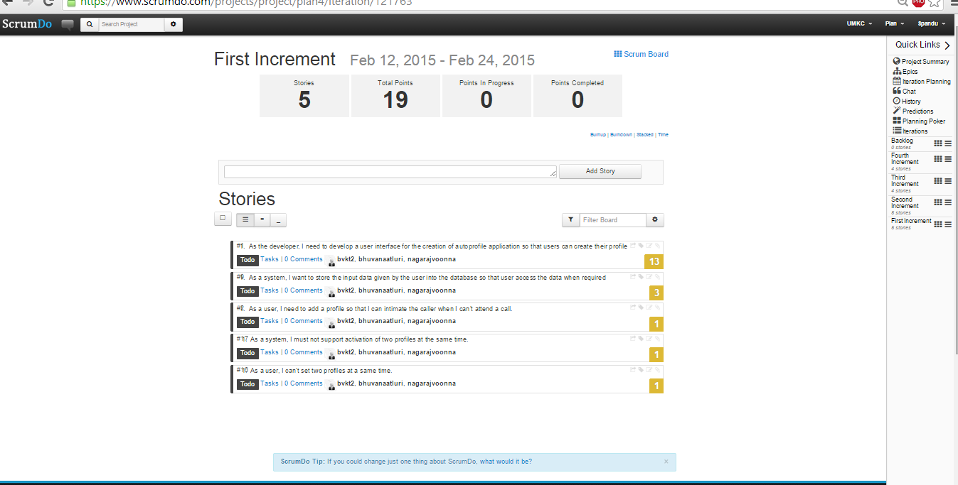

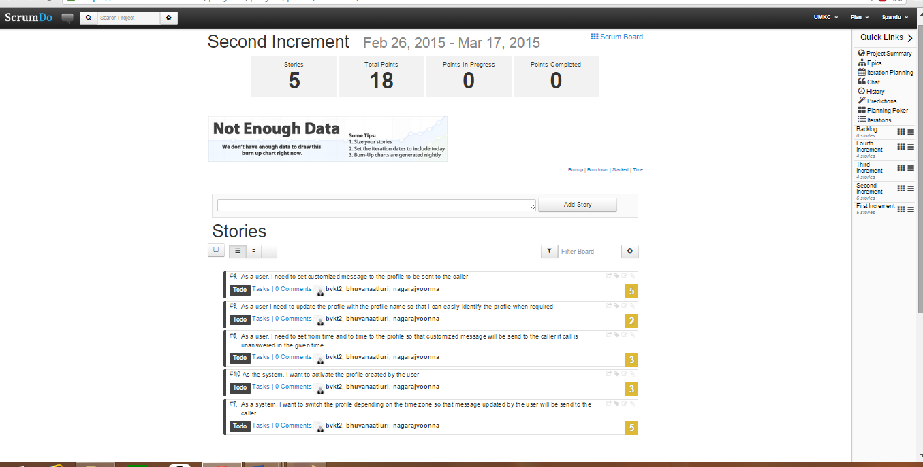

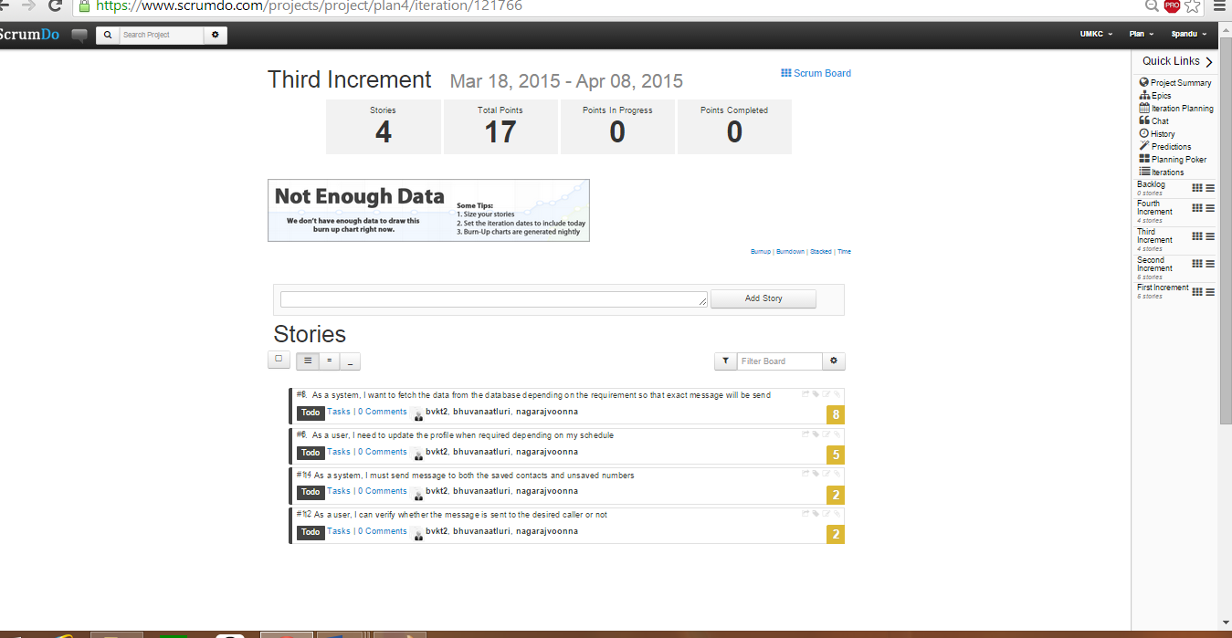

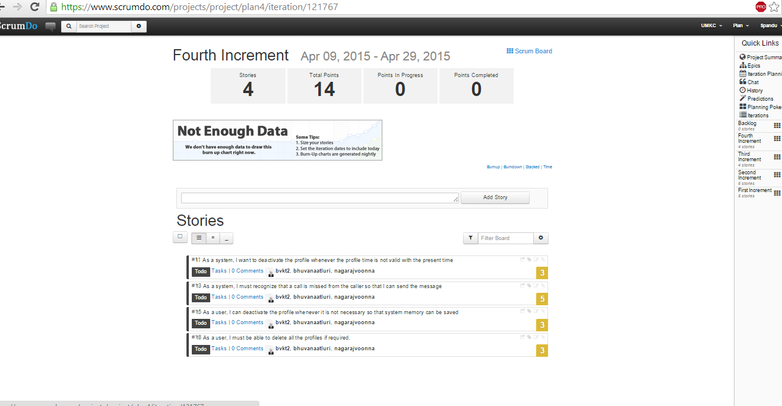

**VI. INCREMENT 1**

**Import Existing Services/API**

There are no external API used as of now.

**Detail Design**

**User Stories:**

We have four stories in Iteration1

1. As the developer, I need to develop a user interface for the creation of auto profile application so that users can create their profile
2. As a system, I want to store the input data given by the user into the database so that user access the data when required
3. As a user, I need to add a profile so that I can intimate the caller when I can't attend a call.
4. As a user, I can create multiple profiles with different timings.

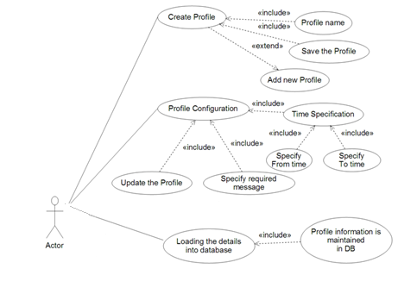

**Description:**

**Creating own Profile module**

In this module we have to create our own custom profile name. It’s purely depends on our requirement. This means we provide the profile name & message as per our requirement and save the profile and further the profile can be displayed in the list format

**Creating SQLite Database module**

In this module we are creating SQLite Database, where Time of the profile and the specified message can be stored in the database. In order to store all the details database is required.

**Configuring Profile**

In this module we create our timings like (To_Time and From_Time) i.e., we create a schedule. For each and every profile To Time and From Time is specified in order to activate the profile. We specify the message as per our requirement this means required message by the user. As per the time specifications only the profile is activated. Inserting time values in to the database and updating the profile is done in this module.

**Sequence Diagrams:**

**For Creating Profile:-**

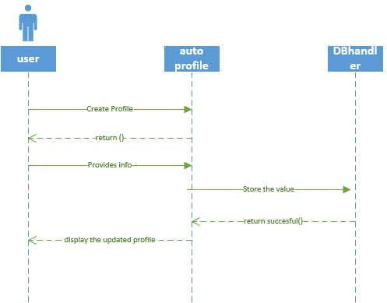

**For Updating Profile:-**

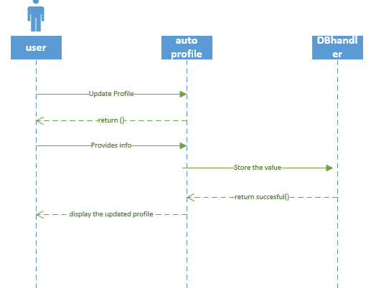

**Class Diagram:**

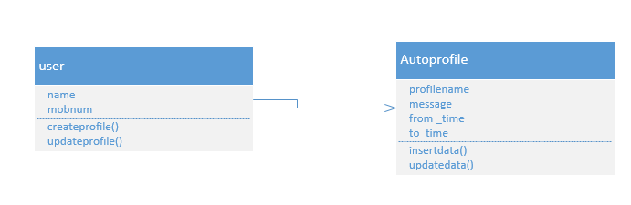**Design of Mobile Client Interface:**

Mobile client interface is an Android application which is a rich client. In the first increment our app consists of 4 different screens. The starting page allows the user to select add profile or activate. A profile page to have the profile name and message to be delivered. Two different time pages to select the to time and from time.

1. In this screen we can add the profile and also update the profile

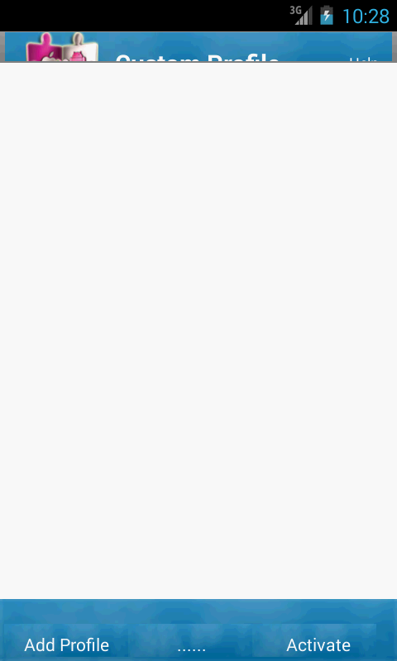

1. Clicking on add profile button a dialog box is displayed on the screen showing profile and message fields.

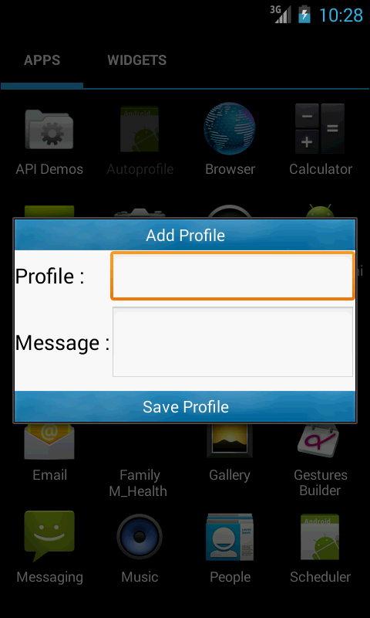

1. We enter and save the profile name and message to be sent to caller.

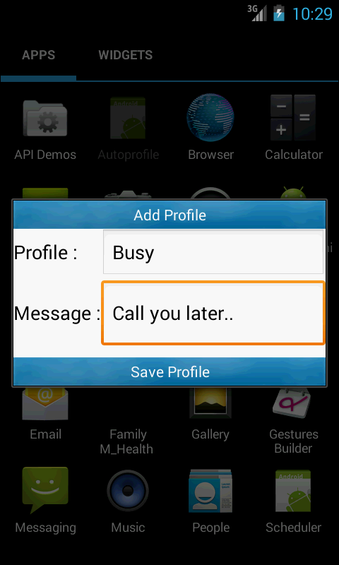

1. The saved profile is displayed on the home screen.

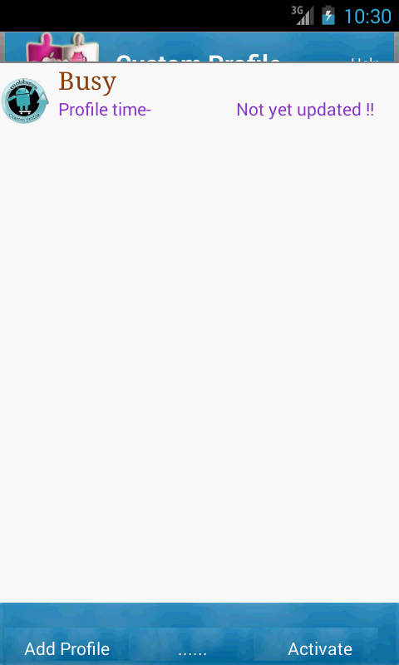

1. When clicked on saved profile a new dialog box is displayed with profile name, from time, to time, modes and message fields along with an update button.

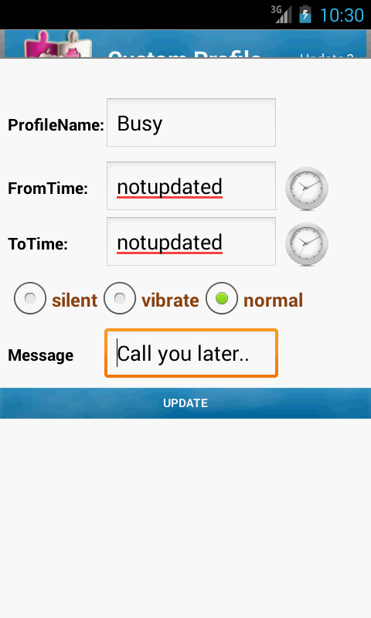

**6.**In this dialog box, we set from time.

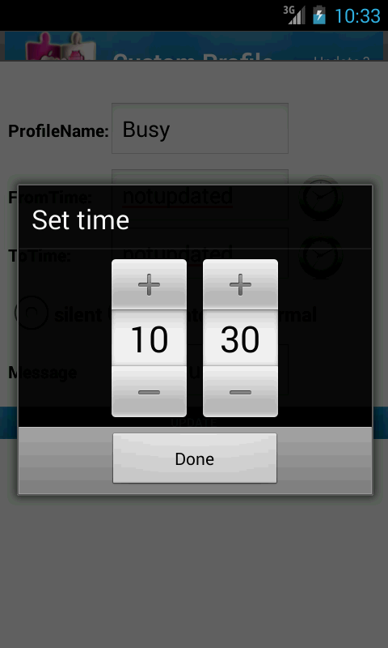

**7.**In this dialogbox, we set to time.

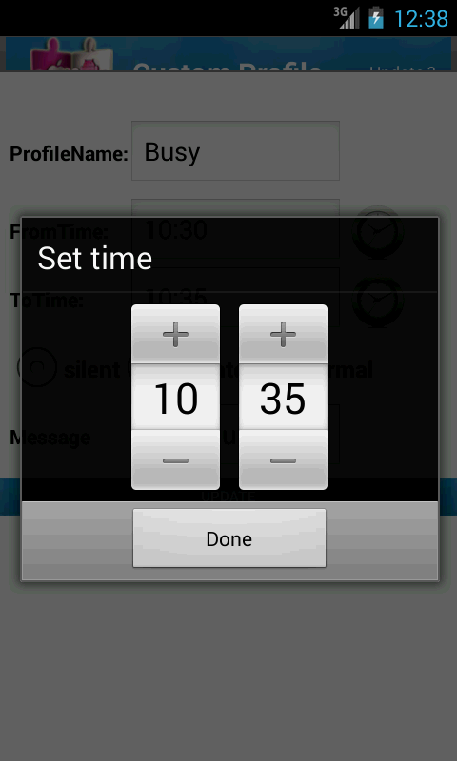

**8.**Profile updated is displayed on the home screen with the updated information

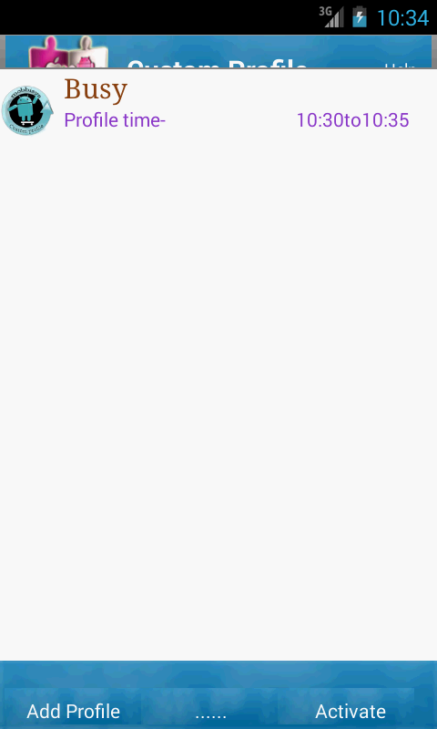

**Issues/Concerns:**

* As we are new to android we faced some problems regarding the database connections.
* We faced build issues.

**VII. INCREMENT II**

**Project Goal:**

Till now we have concentrated on sending messages, images and emails automatically whenever we are unable to attend the calls from the caller and missed call is detected. The message consists of the reason for not attending the call. If there is an emergency situation to the caller the receiver must be notified to attend the call or to communicate with the caller immediately. To get notified in case of emergency situation, the receiver sets the profile message as, in the case of the emergency reply me as “help”. When the caller gets the automatic message from the caller, then if in the case of emergency situation he replies with “help” message to the receiver. When the receiver receives help message then the notification sound will be triggered. The notification will be triggered even if the phone is in silent or vibration mode.

**Detail Design**

**User Stories:**

We have four stories in iteration4

1. As a developer, I need to send the message to the caller containing the message called reply me with “help” in case of emergency.

2. As a developer, I need to filter the messages received from the caller.

1. As a developer, I need to identify if any received message content consists of the “help” message.
2. As a developer, I need to notify in case of the emergency i.e. if any hep message is received.

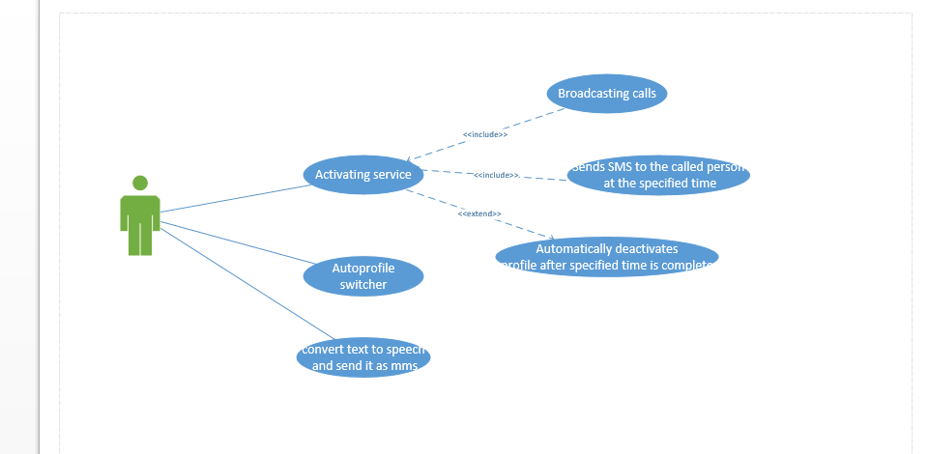

Description:

**Activating Profile Module**

In this module we activate our custom profile. This means we activate one or more of our saved profiles. And there should not exit two profiles at the same time. We are also implementing auto profile switcher, so that multiple profiles can be activated at one particular time. As soon as the profile is activated, the application starts working.

**Activate Service Module**

This module will provide 24*7 services to our custom profile this means activation of the profile is possible at any time. Activating the service means after setting the Timings and specifying message we activate the profile then the service is activated.

**Broad casting call and sending SMS module**

This module plays key role in whole system, it will broadcast the call, and if we have not attended the call it automatically sends the message to concerned call person. And it will notify us that the message is sent and delivered. Here we are also converting the text message in to voice message and sending it in the form of multimedia message.

**Sequence Diagrams:**

For Profile Activation:-

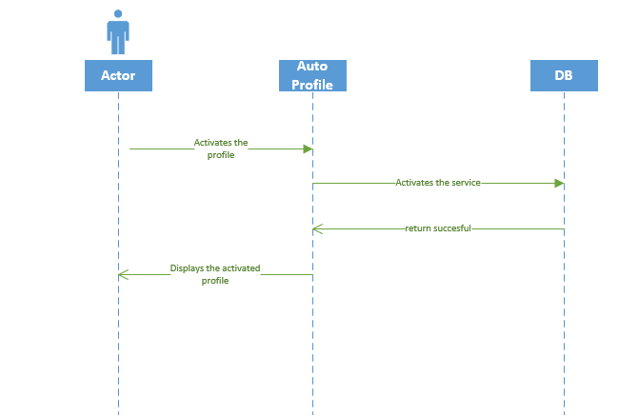

For Activating service and Broadcasting message:-

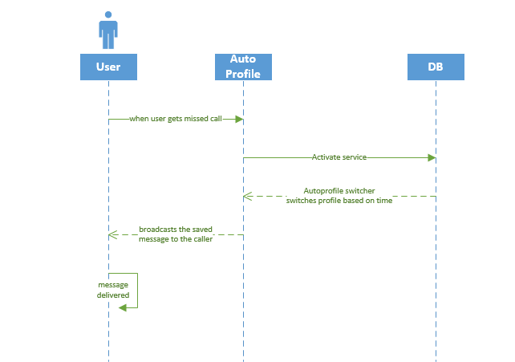

Class Diagram:

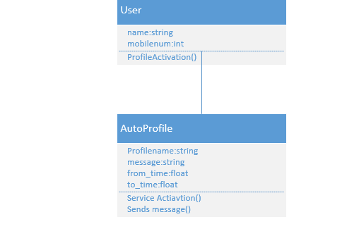

**Design of Mobile Client Interface:**

Mobile client interface is an Android application which is a rich client. In this increment our app consists of 4 different screens. The following are the screenshots of our application:

1. The saved profile is displayed on the home screen.

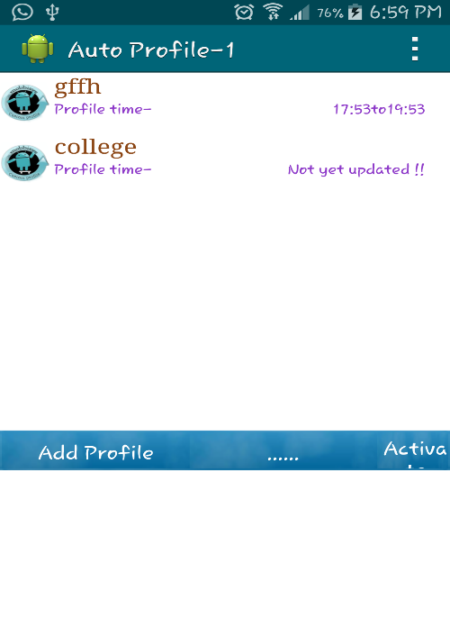

1. The saved profile is activated.

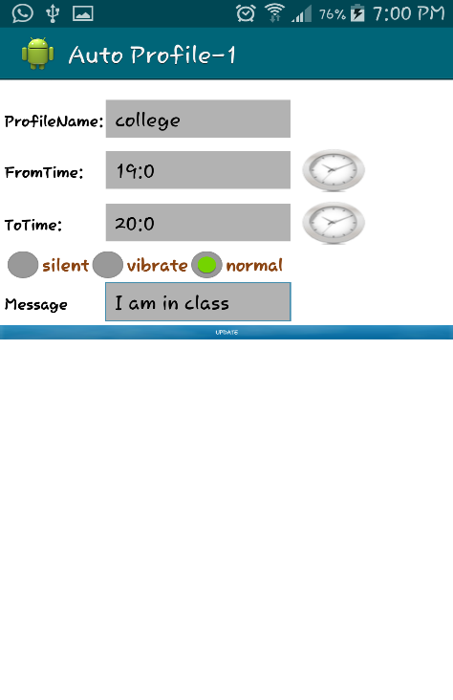

1. Profile updated is displayed on the home screen with the updated information

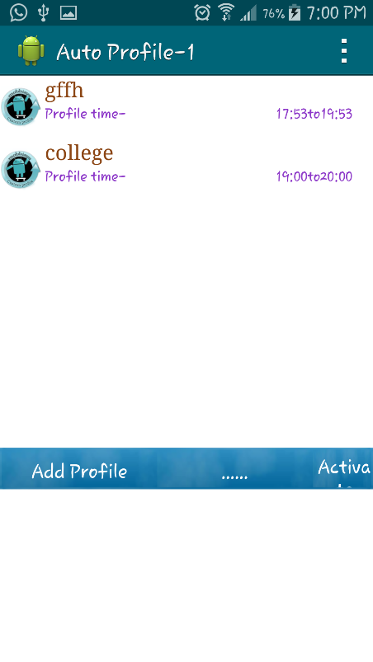

1. When we get a missed call, the service is activated

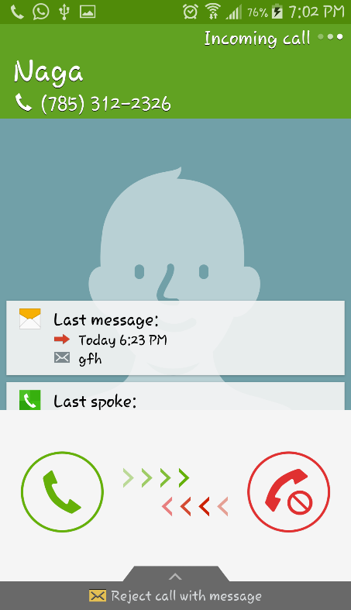 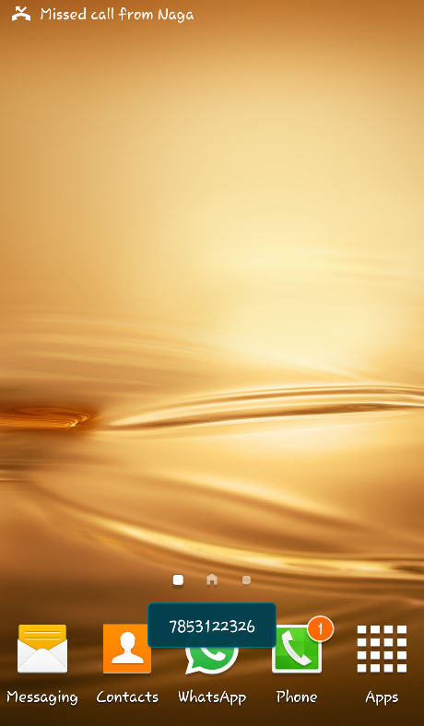

1. Pop will be displayed

 

1. We can view the sent message.

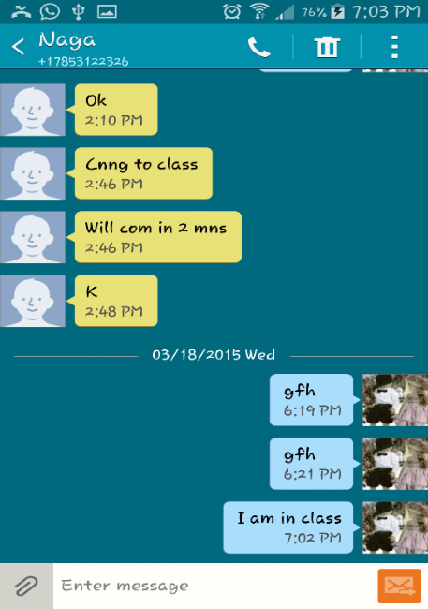

**Work To be completed:**

1. We need to convert the text to speech and broadcast it as a message.

**Issues/Concerns:**

* We face difficulty in text to speech conversion.
* We are unable to save the audio.wav file, we are working on it.

**VIII. INCREMENT III**

**Import Existing Services/API**

**Service:** Google mail

Description: To notify the caller, reason for not attending the calls.

**Detail Design**

**User Stories:**

We have four stories in iteration 3

1. As a developer, I need to send an email to the caller in order to inform him the reason for not attending the call.

2. As a developer, I am sending a picture to the caller as an mms for better view.

3. As a developer, I should be able to delete profiles which I feel unwanted.

4. As a developer, I should make sure, that at the same time two profiles should not be added.

Use case:

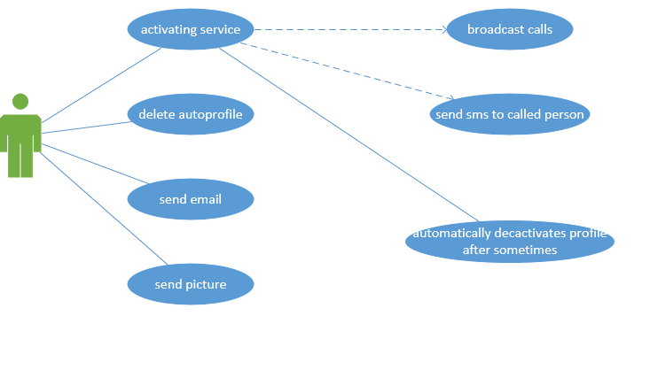

Description:

**Sending Email:**

In this module, we implemented an extension to our auto-profiling. In the previous increment we just sent a message to the called person when we not attended the call. But in this increment we send an email in addition to the message. The body of the email and the subject of the email will be set automatically, and we need to just send the email.

**Sending Picture**

In this module, we implemented an extra feature to our project, i.e. along with the message and email we are sending an image to the caller. By sending the image we can even better convey our message to the caller. And by this we can make our project even more interactive.

**Delete Profile:**

In this module, we implemented code to delete the already created profile. That is if we no longer want that profile, it is of no use. So we added this delete feature to our application. We can delete all the profiles at the same time and we will implement this in the next iteration.

**Colliding Schedules:**

In this module, we worked on colliding schedules i.e. one should not able to create two profiles at the same time. The application should restrict the user from creating such type of profiles.

**Sequence Diagrams:**

For Sending Email:-

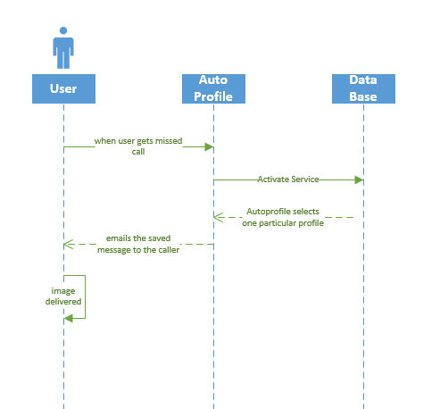

For Sending image:-

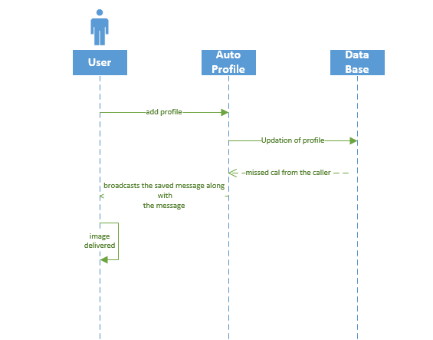

For Deleting Profile:

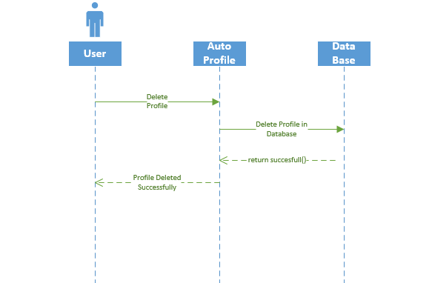

Class Diagram:

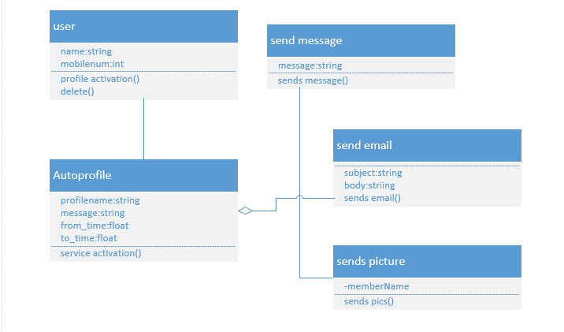

**Design of Mobile Client Interface:**

The following are the screenshots of our how our application works:

1. If we set two profiles at the same time a pop will be displayed.

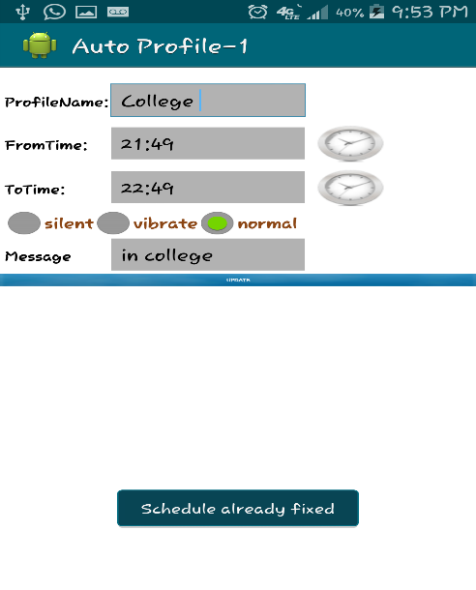

2. Sending image along with the message for interactive display.

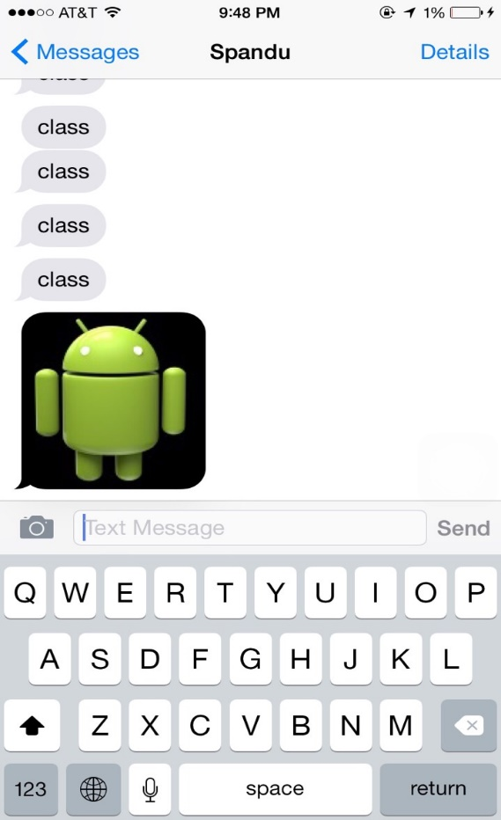

3. When a missed call is recorded in the profile set time then a pop-up appears to select the service to send the email.

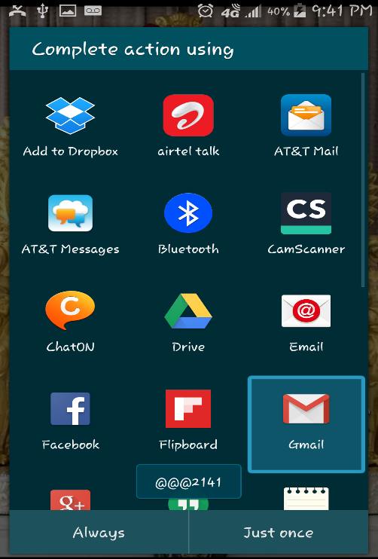

4. An email is set up in the following way:

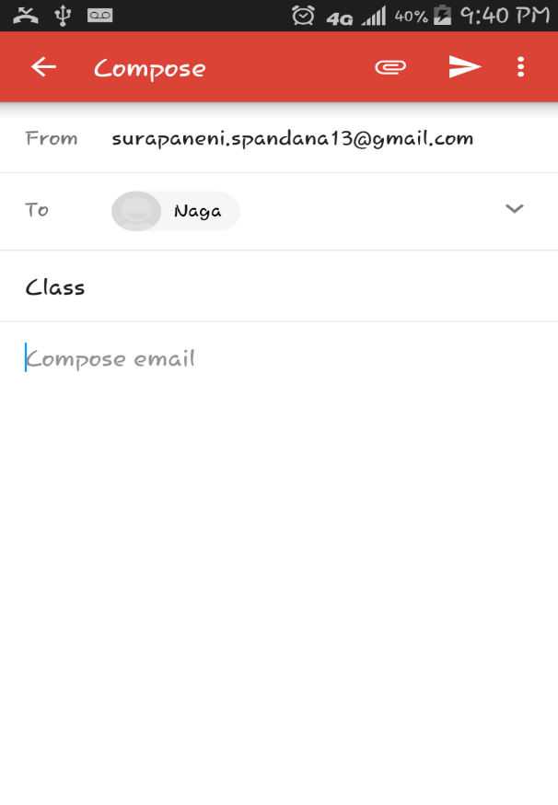

5. The called person will get the email in this way:

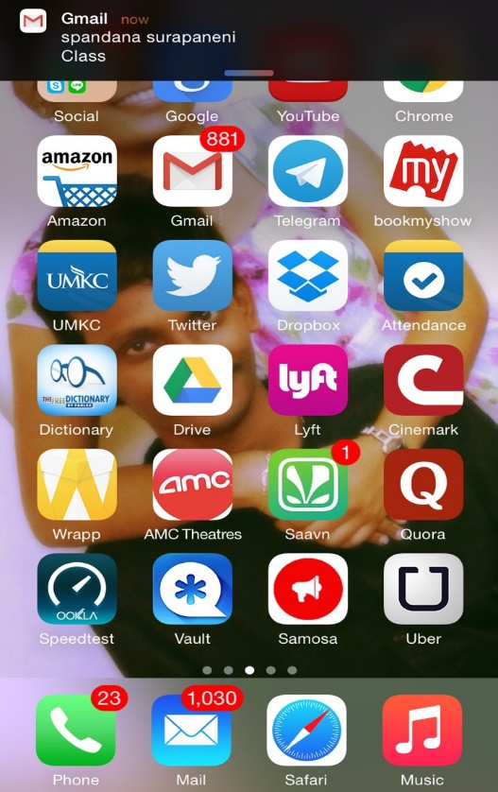

TESTING:

Functional Testing:

Functional testing is nothing but testing the application and validate the behavior of an application, it defines the systems is working in the specified manner or not. In this the tester validates the application whether the application meets the specified requirements or not. It concentrates on the customer requirements whether the customer is satisfied or not.

Functional testing of our application involves testing the functionalities of the application such as creating a profile, saving a profile, deleting a profile, sending message, sending email, text to speech conversion, sending an image when a call is rejected.

Deployment Testing:

It is a type of production testing to test whether it is working good in production or not which is performed after the code is deployed on the system. In this testing we deploy the application on the system and check whether it is working when the supporting files are removed from the system if it works then the application is not working properly and if it does not work then the application is said to be working normally.

Run time Performance testing is used to find the speed of a computer of the effectiveness of a network or a software program or a device. Testing performance involves measuring the response time i.e the time to get a response when a request is submitted. In other words it is also defined as MIPS which stands for millions of instructions per second which the system functions properly. In performance testing quality attributes such as the reliability, resource usage, interoperability, and scalability are evaluated.

Attributes in Performance Testing:

Speed, Scalability, Stability, Reliability

Speed:

The speed of the application refers to the fastness with which the application loads when it is initiated. The speed test helps us to know about the application whether it is loading fast, slow, and is it lagging for any reason.

The speed of our application on multiple android versions is calculated as follows:

1. Gingerbread:

We calculated the speed of the application by running it on various android versions several times. The time taken on average to run our application on Ginger bread version is 15 sec. To send the message from the caller to the calle is 10 seconds. We have given the screen shot when we use the app on the ginger bread version.

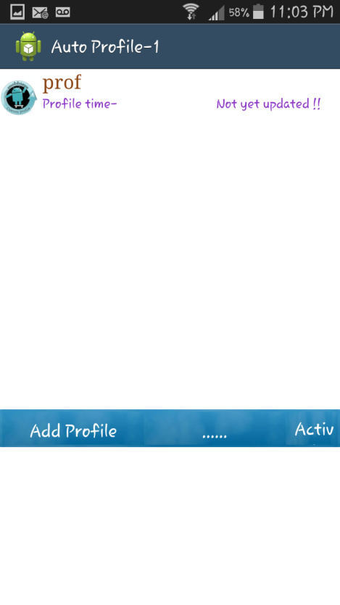

2. Honeycomb:

We calculated the speed of the application on honeycomb version as 12 sec. We have calculated this by running the application various times on the Honeycomb version. The time taking to send the message from the caller to the calle is 8 seconds.

3. Ice Cream Sandwich:

We calculated the application speed on Ice Cream Sandwich version as 10 sec, by running the application several times on this version. The time to send the message from the caller to the calle is 5 seconds.

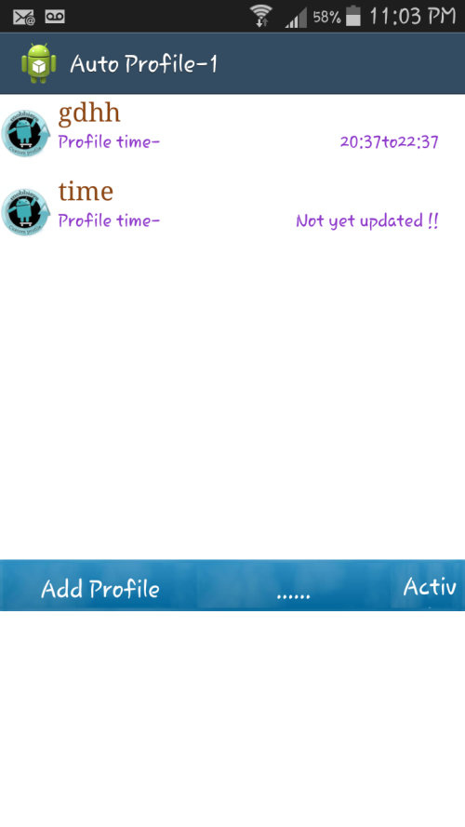

4. Jelly Bean:

The speed on the jelly bean version to run the application is 9 sec, the message is send to the calle in 4 seconds.

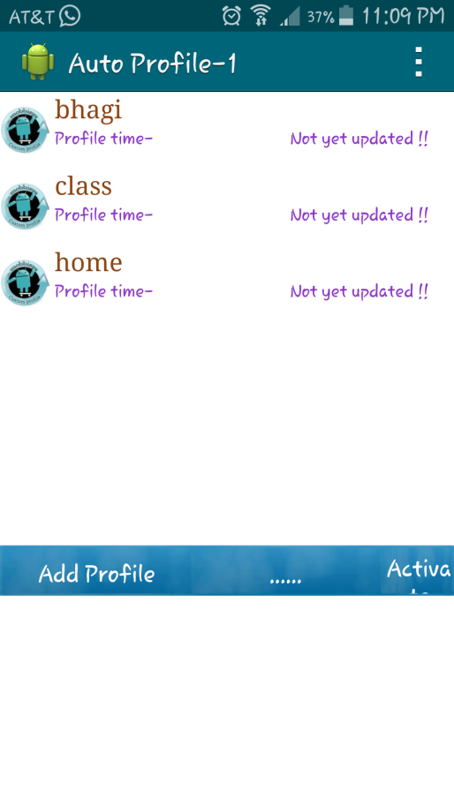

5.Kit Kat:

The speed on the kit kat version is 7 sec, and the time to send the message from the calle to the caller is 2 seconds.

Scalability:

It is nothing but the capability of a system to handle the increasing work in an effective way or the capability to grow so that to accommodate that growth. It refers to the capability of a system to with stand the increased load to produce an increased output when the resources are being added.

In our system the scalability is defined as the performance of the system when the number of profiles are increased in the application, though the profiles are increased the applications works usually by activating the profile which is set for the specified time.

Stability :

The stability of the system is defined if the application is stable for different varying loads.

In our system context when different profiles are used at a time only the first profile is active and the message will be displayed from the first profile only and the remaining profiles are said to be inactive and the messages are not displayed though the profiles are set for the same time.

Reliability:

The reliability of a system is defined as the performance of the system during an extended time period for various sets of test conditions, it is performed before deployment to discover and remove any failures from the system so as the system can function well after deployment. The main purpose of reliability testing is to find the reliability of the product whether the application meets the customer's requirements or not.

Application is said to be reliable when the application gives the same output repeatedly, is the probability of the application to perform well in the specified environment.

In our application reliability is tested by checking whether the system works for various sets of profiles set for different times and the message is delivered properly or not. The reliability is found to be successful when the system meets the user requirements i. e the profile should work properly when set for a particular time and the message should be send as it is important to send the message for the calle, also an email should be send to the person when required with an image.

**Work To be completed:**

1. We need to customize our application, so that we can send different messages to different groups such as family group, friends group etc.

**IX. INCREMENT IV**

**Project Goal:**

Till now we have concentrated on sending messages, images and emails automatically whenever we are unable to attend the calls from the caller and missed call is detected. The message consists of the reason for not attending the call. If there is an emergency situation to the caller the receiver must be notified to attend the call or to communicate with the caller immediately. To get notified in case of emergency situation, the receiver sets the profile message as, in the case of the emergency reply me as “help”. When the caller gets the automatic message from the caller, then if in the case of emergency situation he replies with “help” message to the receiver. When the receiver receives help message then the notification sound will be triggered. The notification will be triggered even if the phone is in silent or vibration mode.

**Detail Design**

**User Stories:**

We have four stories in iteration4

1. As a developer, I need to send the message to the caller containing the message called reply me with “help” in case of emergency.

2. As a developer, I need to filter the messages received from the caller.

3. As a developer, I need to identify if any received message content consists of the “help” message.

4. As a developer, I need to notify in case of the emergency i.e. if any hep message is received.

**Description:** Whenever help message is received from the caller, the application matches it with the predefined text and if the matching occurs it notifies to the alarm handler and an alarm sound will be notified that the caller is in emergency situation.

**Sequence diagram:**

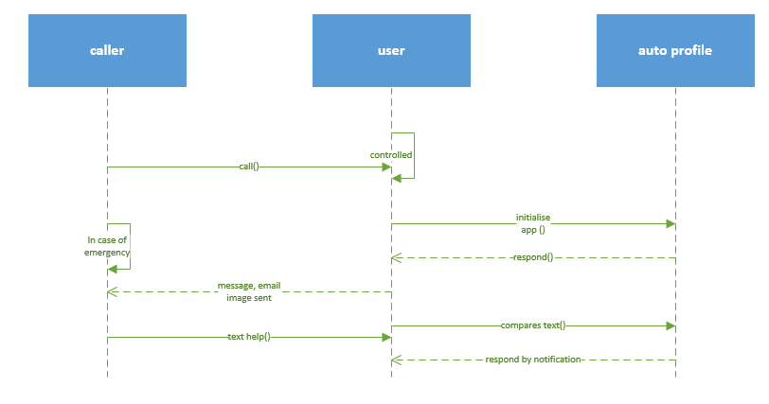

**Class diagram:**

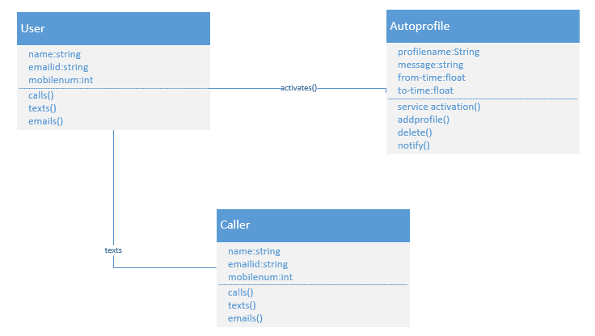

**Testing:**

Functional Testing:

Functional Testing is a process of quality assurance and it’s a type of black box testing that depends on the test cases on the specifications of the software product under test. The product and the software functionality are tested by inputting and testing the output, and the inner program features are considered rarely. The functionality of the system is tested normally. It tests just certain functionality of the system i.e. a part of the system.

We have done functional testing of auto profile by using ranorex studio, we have downloaded ranorex studio and open an empty recording file.

Start-programs-Ranorex-Ranorex studio-open empty recording file-new test solution-blank test suite project- select c# project-ranorex c# test suite-specify name-location for test suite-create.

This opens the new suite project and to start recording we have to add a device such as the mobile device and add it to the recording window. To start the application we have to select the device and start recording by clicking on the continue evaluation, start recording select mobile or desktop or web. For our application we have to select mobile and the recording is started automatically by selecting the web application and then the key press are recorded automatically and the time taken for each key press is recorded such as the timeout for the click and the type of action such as click, close window, log etc. The actions can be key press, key sequence, mouse, wait for, validate etc. The time out indicates the time taken for the click and the time in which it expires.

After recording press the stop button and then the log is created by playing the recorded video, then the results are displayed as the time, level, category, and message.

Below are the screenshots of the application when creating a profile and activating the profile, and deleting the profile.

Here we record the actions in the application by starting the profile and adding a profile and updating and deleting the profile and in the final we deactivate the profile and then deleting all the applications.

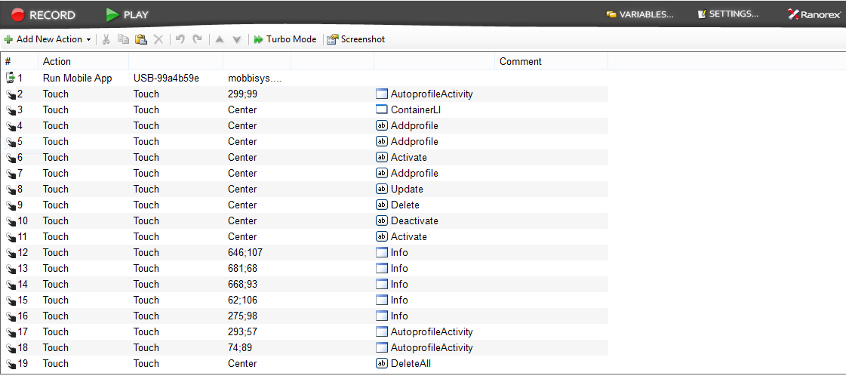

These are the results of the test case which shows the time and the category of the event and the message displayed by clicking the event.

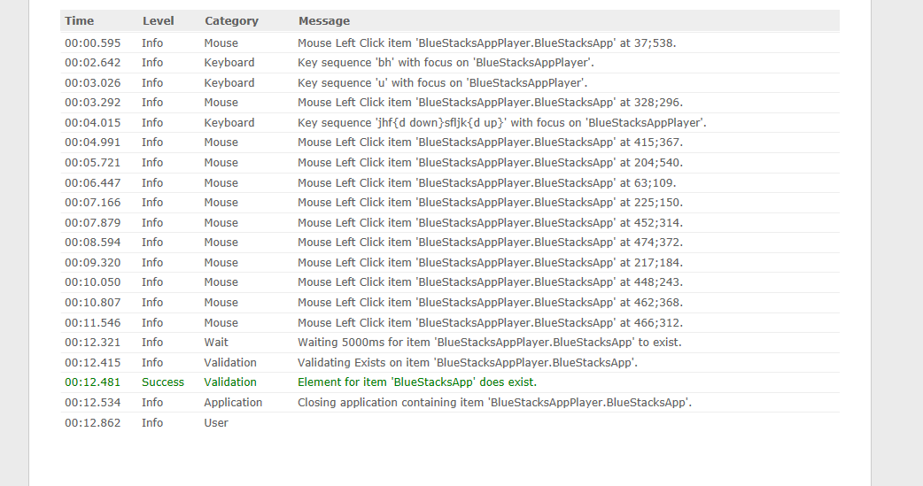

Final recording of the application giving a success output and it shows the execution time and the number of errors produced.

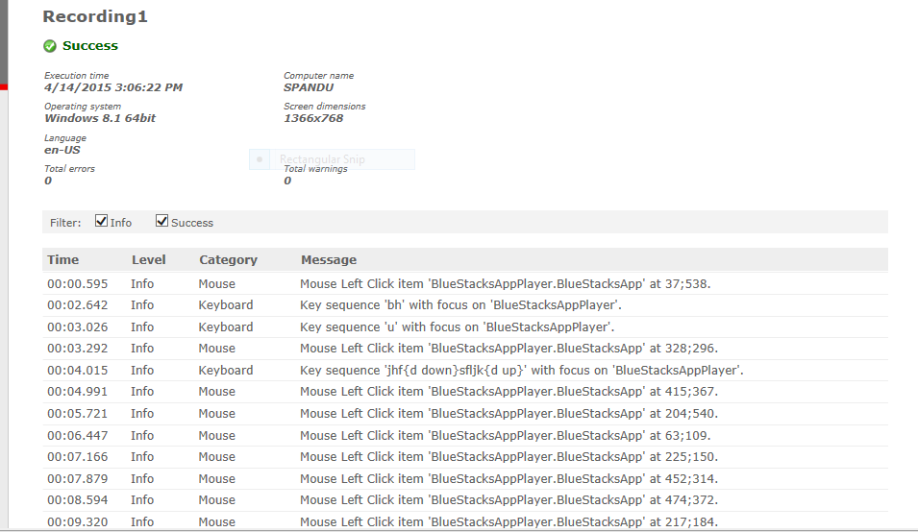

Here is another result of the event recording using the blue stack app player, the events are the same click on activating and deleting the profile and updating the profile.

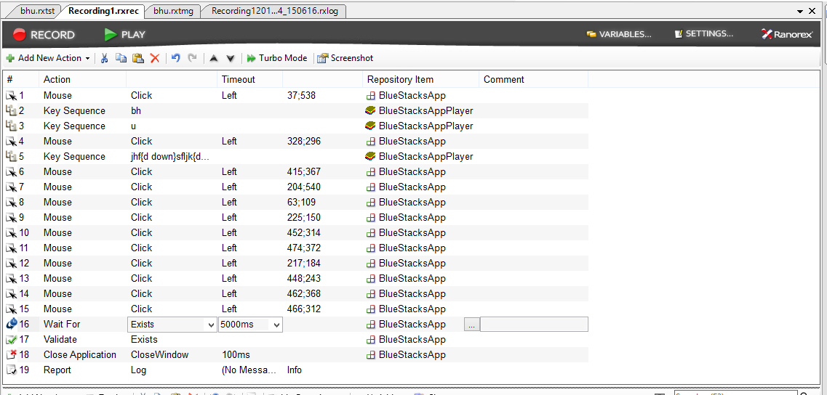

The results of the above recording are success and there are 0 errors for the above recording.

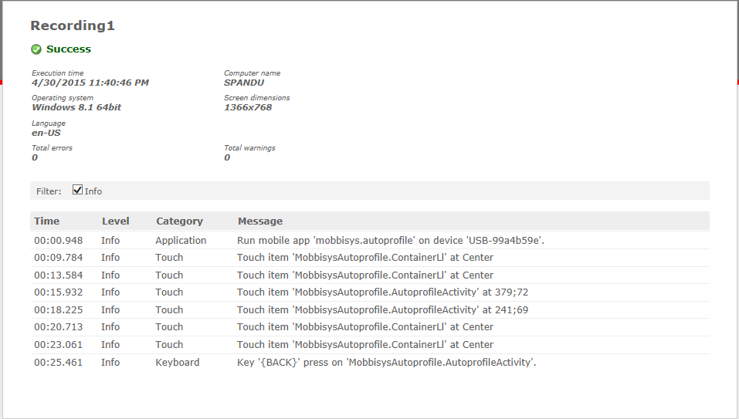

The results of the above events is given as output such as success and it denotes whether the application is success or failed or blocked.

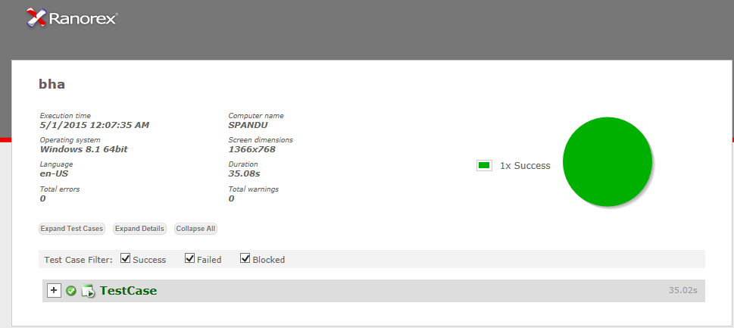

**Implementation:**

1. Whenever the receiver received “help” message then the application detects the keyword. 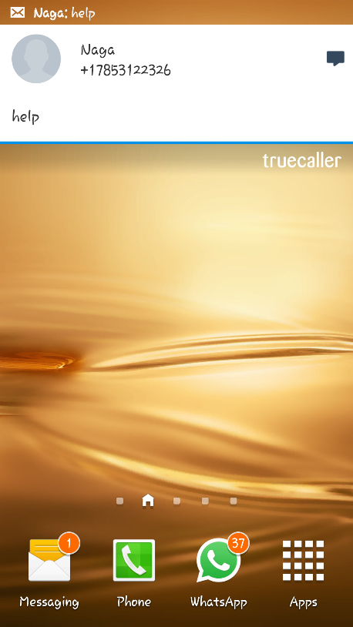

b) Whenever the keyword is detected receiver will be notified with the notification sound.

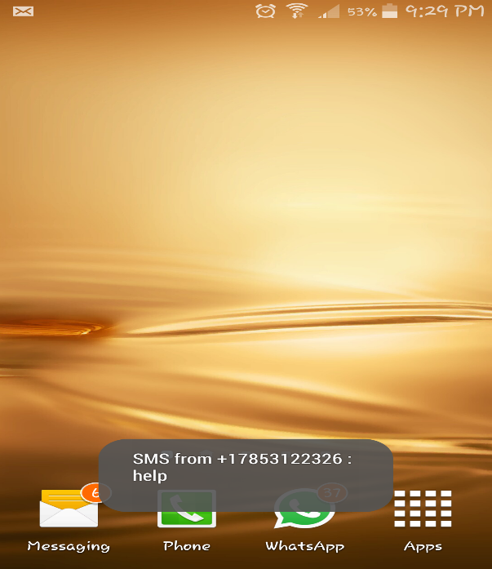

**X. Presentation Material:**

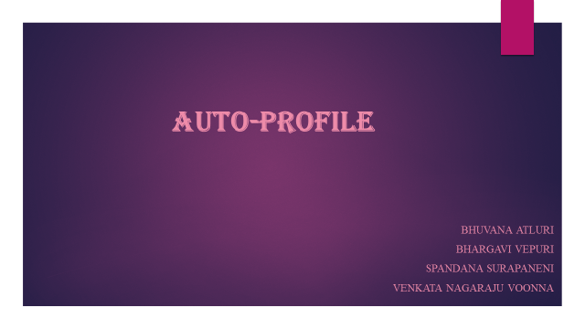 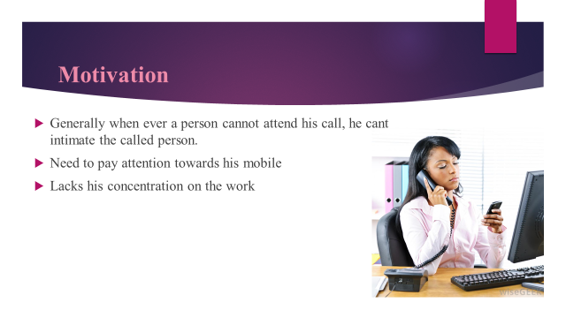

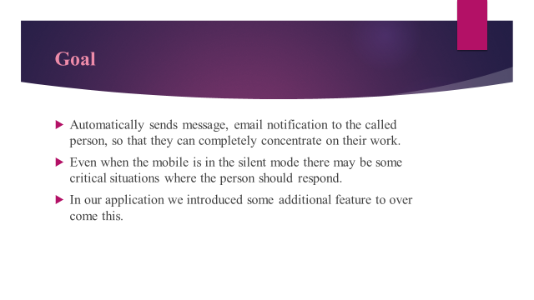

**X1.References:**

[1] http://developer.android.com/index.html

[2] http://www.w3schools.com

[3] https://developers.google.com/gmail/api/guides/sending

[4] http://developer.android.com/reference/android/telephony/SmsManager.html

[5] http://android-developers.blogspot.com

[6] https://developer.android.com/training/beam-files/send-files.html

[7] http://developer.android.com/reference/android/app/AlarmManager.html

[8] http://developer.android.com/reference/android/app/Service.html

[9] https://developer.android.com/reference/android/provider/Telephony.html

[10] http://developer.android.com/reference/android/database/sqlite/package-summary.html

[11] http://www.ranorex.com

[12] http://www.ranorex.com/support/user-guide-20.html

**XII. Acknowledgment:**

This work was done in partial fulfillment of the requirements of

CS551: Advanced Software Engineering,

CSEE Department,

University of Missouri – Kansas City (Spring 2015).

Instructor: Dr. Yugyung Lee,

TA: Malathy  Krishnan,   Mayanka  Chandrashekar,  Bharat  Viswanadham.